General Gymnastics (Floor and Vault) – Free-Style Gymnastics – Disabilities Gymnastics – Trampoline
Synchro Trampoline – Double Mini Trampoline (DMT) – Disabilities Trampolining – Acro Gym
UPDATED 06/01/22 (Trampoline Voluntary routine)
Virtual Competition Pack
Jan 2022 – Dec 2022

Our Supporters: -
Membership services for Clubs, Coaches and Participants www.gymnasticbritannia.org
Music for Gymnastics and Cheerleading www.gymjamz.co.uk

Competition Dates:
Event | Event Area | Entry Form and Fee Dates | Submission of Video Dates
Trampolining  Disability Trampolining  Synchro Trampolining  Double Mini Trampoline (DMT) | Regional & National | New Updated Date  22 – 28 February 2022 | New Updated Date  01 – 12 March 2022
General Gym (Floor & Vault)  Disability Gym (Floor & Vault) | Regional & National | 01 – 08 March 2022 | 12 – 21 March 2022
Free-Style Gym | National | 01 – 08 June 2022 | 12 – 21 June 2022
Trampolining,  Double Mini Tramp (DMT)  Synchro Trampolining  Disability Trampolining  Disability Gymnastics | National | 01 – 08 October 2022 | 12 – 21 October 2022
Acro Gymnastics (Rules TBC) | National | 01 – 08 November 2022 | 12 -21 November 2022
Quality Assurance Scheme for Clubs and Leisure Centres.
Visit: winstrada.com/inclusion/gymquest.shtml

Page: Menu:
02 Competition dates / submission dates.
03 Menu
04 – 06 Common rules for all events.
06 – 07 Trampolining
08 Synchronised Trampolining
Page: Menu:
08 – 10 Disability Trampolining
11 Double Mini Trampoline (DMT)
12 – 14 Gymnastics
14 – 17 Disability Gymnastics
17 – 18 Free-style Gymnastics

'Train the Trainers'
Club, Centre or School Specific, Gymnastics Coach Training Course

This course is designed to equip and validate a senior coach to oversee all future basic Gymnastics coach training within their specified club, centre or school. It will enable the course member to train senior coaches within their specified club, centre or school to lead Gymnastics sessions within that same specified club or centre. The course is open to those who have already qualified in Gymnastics to a minimum Level 2 or the Authority Recreational Gymnastics training course, as detailed on our website, and are experienced in leading Gymnastics Sessions.
For Information E-Mail: info@gymnasticbritannia.org
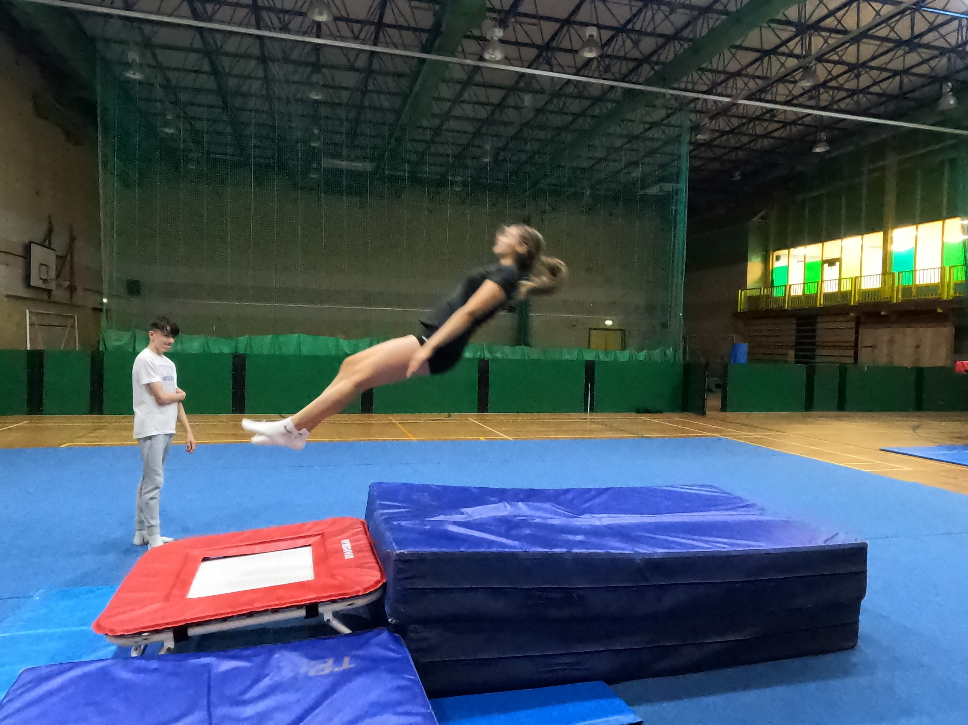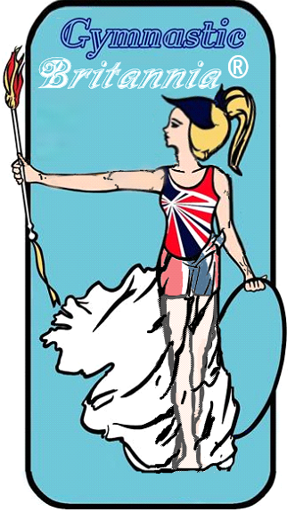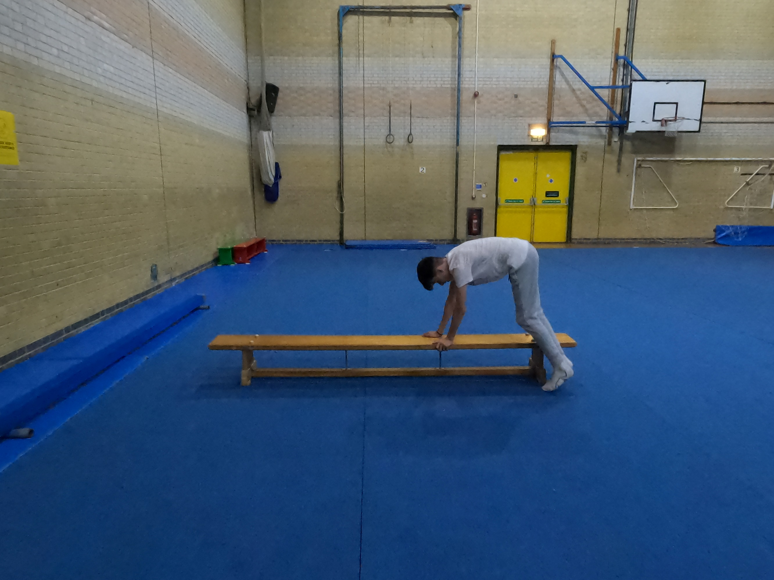
Gymnastics Coming Early 2022.
The 'Train the Trainers' course will be club, centre or school specific. The course model will comprise the following: a) A two day practical, which will cover the common core areas b) A distance learning module which will relate to the theory aspects and development of protocols for training. c) A final assessment day. The course content will include the writing of a policy protocol document for the implementation of Gymnastics sessions and staff training within the club or centre. The final certification will be issued to all participants on the satisfactory completion of the course and will be owned by each club and tutor.
Recognised and Approved by Gymnastic Britannia Ltd

- Competition Rules common to all events.

- Everyone is advised to read the information contained, any queries should be directed via our website.

- If something specific has been omitted then the chair of judges, and / or the competition organiser shall rectify and give a score or make a decision based on using fairness for all involved.

- All videos submitted must be in line with video requirements (see section 2)

- All judging will be carried out by independent ASUK Virtual Competition Judges who will be qualified via a Governing Body or where no specific judging qualification is available, there will be a selection of judges trained specifically for the discipline by AuthoritySportsUK Competition organiser and in line with our rules. So therefore, I am pleased to say you do not have to supply judges.

- All entries will be accepted for participants who are coached by a qualified coach / instructor / teacher and have insurance to do so, routines must be carried out in a safe sporting environment, and under the direct supervision of a qualified person.

- Videos must be uploaded by the closing date any late entries will be rejected unless you receive prior written agreement from the competition organiser.

- Once all entries have been received, it is aimed that all results will be released within 2 weeks after closing date, however we aim for this to be done a lot quicker where possible.

- All rules are required to be adhered to otherwise a score may not be given.

- Filming Guidance for all disciplines.

- Clubs, coaches and organisations submitting videos of routines must ensure that they have written permission for having their image used and potentially published, from the guardian of the participant for under 18’s, over 18’s classified as vulnerable adults. For over 18’s permission from the performer. This must be done for anyone who is shown within the video including coaches or relevant persons.

- AuthoritySportsUK, Gymnastic Britannia or any associated organisations cannot be held responsible or liable for any misuse of image rights or any financial claims that arise thereof.

- To ensure best potential quality for filming, you can use Camera, Smart Phones, or Tablets but ensure the routine can be seen clearly to ensure they can be judged.

- The filming should be done in Landscape to ensure maximum visibility and appropriate distance away from the routine so that the whole performance area can be seen adequately including the full performers skills. The Recording device should ideally be on a stand or tripod to ensure stability and should not be moved side to side or up and down.

- To ensure that the performers can be seen adequately please ensure it is evenly lit.
- Details should be shown on a card at beginning prior to commencement of performance (See requirements in section 3).

- During filming there should be no verbal instructions from coach, and any music must be within requirements and in line with regulations, avoiding Andrew Lloyd Webber, Disney Music.

- All filming should be clear without blurring, any routines or displays that are blurred may not be judged, this will be down to the chair of judges to decide if it can be judged fairly and within rules.

- Anyone competing must compete using adequate matting and on equipment deemed to be safe.

- General Video Guidance.

- At the start of the video the registration symbol must be used which is unique to your club and discipline specific, in addition each routine should have full name written on a white background paper or whiteboard. (to receive the registration symbols we require the registration form with full payment.)

- Filming of routines / displays, may only be done after receiving your registration symbol, and the showing the name and symbol must be done within the video whilst recording and not edited in later on, in one continuous recording.

- Each event type will have a different symbol associated.

- At start and end of the routine / display there should be a Presentation to camera (otherwise points may be deducted.)

- See Discipline specific sections for any adjustments required for filming and these must be complied with.

- All routines or displays must be complete.

- Fees

- Each discipline will show the allocated entry fees. (Gymnastic Britannia Members Receive 10% discount off Individual entry fees).

- Top 3 of each group.

- The top 3 of each group will be automatically put into the National Event at no additional charge. The scores that were given for the regional rounds will be automatically used.

- The top 3 or each group will receive a trophy, all other entries will receive a certificate of participation with their placing upon it.

- Subject to competition team medals may be applicable.

- Exceptional Circumstances (Regions)

- Where a age group or discipline does not have enough entries, we reserve the right to combine them with another region to make a group.

- Disciplines

- Trampolining
- Disability Trampolining
- Trampoline Synchro
- DMT (Double Mini Trampoline)
- General Gymnastics
- Disability Gymnastics
- Acro Gymnastics (Rules for this will be released in March 2022)
- Free-Style Gymnastics (National Event)

- Trampolining

- Entry fees

- £10.00 for individual entry (Per Person) (Trampoline or DMT)

- £02.00 on top of individual entry fee for a team of up to 4 members (Trampoline Event Only)

- £20.00 for Synchro Pair entry (Synchro Trampoline)

- £17.00 for individual entry for 2 events (Trampoline, Trampoline Synchro (Per Person) or DMT)

- £25.00 for individual entry for 3 events (Trampoline, Trampoline Synchro (Per Person) or DMT)

- Rules

- Execution deductions will be taken off per skill 0.0-0.05, we are basing scores on execution only we shall not be recording horizontal displacement (HD) or time of flight (TOF) scores.

- In the set routine missing a skill will mean the routine will stop being judged at the last set skill performed

- Instability at end of routine 0.1-0.2

- Not Presenting at beginning or end 0.1 deduction

- The 5 execution judges will have highest and lowest score removed, and middle 3 added together. For voluntary routines that are specified tariff will be added on as normal

- Tiebreak, if 2 people within the top 3 receive the same scores, we shall introduce the average of the highest and lowest score which is normally deducted.

- Age Groups

- U9, U11, U13, U15, U18, O18

- These will be Split into Male, Female (In case of low numbers we reserve the right to combine)

- Competition Attire

- Male / Female gymnasts

- leotard or unitard with or without sleeves

- Gym shorts or trousers

- White trampoline shoes and/or foot covering or of the same colour as the gym trousers

- For reasons of safety, covering the face is not permitted.

- Trampoline shoes and/or white foot covering

- The wearing of jewellery or watches is not permitted during the competition video.

- Rings without gemstones may be worn if they are taped.

- Bandages or support pieces must not create a big contrast with the skin colour.

- Underwear must not be visible.

- Routines: SET

Beginner Intermediate Advanced

- 1. Seat Landing Full Twist Back Somersault
- 2. To Feet Straddle Straddle
- 3. Half Twist Seat Landing Back Somersault to Seat
- 4. Straddle ½ Twist to Seat Landing ½ Twist to Feet
- 5. Full Twist ½ Twist to Feet ½ Twist
- 6. Pike Pike Pike
- 7. Half Twist Back Landing Back Landing
- 8. Tuck ½ Twist ½ Twist to Feet
- 9. Seat Landing Tuck Tuck
- 10. Half Twist to Feet Front Somersault (T) Barani (T)
Voluntary Routine Max 1.2 Tariff Routine Max Tariff 1.6 Max Tariff: 3.00
Max SS Rotation 270 degrees Somersaults with half twists
- Trampoline Synchro

- Entry Fees (Please see trampolining section above)

- Rules

- Execution deductions will be taken off per skill 0.0-0.05, we are basing scores on execution only we shall not be recording horizontal displacement (HD) or time of flight (TOF) scores.

- In the set routine missing a skill will mean the routine will stop been judged at the last set skill performed

- Instability at end of routine 0.1-0.2

- Not Presenting at beginning or end 0.1 deduction

- The 6 execution judges will have highest and lowest score removed, and middle 4 added together (2 judging bed 1, 2 judging bed 2). For voluntary routines that are specified tariff will be added on as normal

- Tiebreak, if 2 Synchro Partners within the top 3 receive the same scores, we shall introduce the average of the highest and lowest score which is normally deducted.

- Any rules that may not be covered will comply with FIG code of Points

- Routine as per Trampoline

- Attire as per Trampoline

- Age groups as per trampoline

- Disability Trampolining (celebration of participation)

- Entry Fees

- £06.00 Individual Entry (Medals will be given for the top 3 within the group)

- £02.00 additional to the Individual Entry for a team of up to 4 (Medals will be given for the top 3 teams within the group)

- Rules as below using Rebound Therapy Competition Scheme.

- Attire as per Trampoline, however if require T-shirt (not baggy) can be tucked into white shorts and wearing white socks.

- Age groups as per trampoline

‘ReboundTherapy.org’ SEN Trampolining competition framework
- The competition will have six grades; 3 to 8. The competition routines are shown below (Grades 1-2 are not included as these are for in person events only)

- Grades 3+ No physical assistance permitted. Verbal prompting, signing and mirroring is permitted for all grades.

- All participants / competitors will have 2 performance routines submitted (even if they are the same)

- The first performance for Grades 3+ will be a compulsory routine. (Routines shown below).

- The second performance for grades 3, 4 and 5 should be a repeat of the first routine.

- The second performance for grades 6, 7 and 8 is a voluntary; it can be a repeat of the first routine or any other routine made up of exercises from the Winstrada scheme, but must not include exercises from a higher grade than that which the student is entering at. (Click here for Grades 6, 7 and 8 exercise list.) The routine should comprise nine contacts for grade 6 and ten contacts for grades 7 and 8.
Scoring and Judging notes – Grades 3 to 8
Grade 3  Tuck jump,  1/2 twist jump,  Star position | Grade 4  Seat drop,  to feet,  Tuck jump,  1/2 twist jump | Grade 5  Star jump,  Seat drop,  to feet,  Tuck jump,  1/2 twist jump,  Straight jump
Grade 6  Straddle jump,  Seat drop,  to feet,  Tuck jump,  1/2 twist jump,  Pike jump,  Seat drop 1/2 twist,  to feet,  Straight jump, | Grade 7  Front drop,  to feet,  Tuck jump,  1/2 twist jump,  Straddle jump,  Seat drop,  to feet,  Pike jump,  Full twist jump,  Straight jump, | Grade 8  Front drop,  to feet,  Straddle jump,  1/2 twist jump,  Seat drop,  1/2/ twist to seat drop,  1/2 twist to feet,  Tuck jump,  Pike jump,  Full twist jump,
Grades 3 to 8; no physical assistance but verbal prompting,
signing and mirroring permitted
All routines for grades 3 and above will have a maximum possible score of 10. They will be marked out of the number of contacts in the routine, then the appropriate number will be added to enable the routine to show a score out of 10, as follows:

- Grade 3 comprises three contacts so will be scored out of 3 and 7 will be added to the form score to bring it up to 10

- Grade 4 comprises four contacts so will be scored out of 4 and 6 will be added.

- Grade 5 comprises six contacts so will be scored out of 6 and 4 will be added.

- Grade 6 comprises nine contacts so will be scored out of 9 and 1 will be added.

- Grades 7 and 8 have ten contacts in the routines so nothing will be added.
Scoring deductions are made as follows:

- Faults: 0.1 to 0.5

- Final ‘landing’ faults – Grades 6, 7 and 8 only: 0.1 to 0.2 for instability

- A missing move in the compulsory (1st routine) will end the routine at that point

- Grades 3, 4 and 5 - No deductions will be made for extra bounces, whether during or after the routine

- Grades 6, 7 and 8 – 0.1 deductions will be made for each extra bounce during the routine.

Other notes:

- All grades – students should attempt to stop and remain in stillness before dismounting

- Grades 4, 7 and 8 – the first move does not necessarily have to start from a standing position

- There will be no tariff (difficulty) scores.

- An optional out bounce is permitted at the end of the routine.

- The routine is deemed to have started once the first skill has been performed, however a maximum of three false starts without penalty will be allowed.

- The routine is deemed to have finished after the last skill plus one out-bounce.

- Competition organisers may, if they wish, decide to award a bonus mark if the routine is performed without any assistance.

- Where there are a number of competitors in medal winning places with the same score, the senior judge should decide the placing based on his / her scoresheet. When that is not possible, the number of extra bounces in the routine should be taken into account.

Medals will be awarded for 1st, 2nd and 3rd places in each category, subject to sufficient number of entrants. It is suggested that if there are only four entrants in a category for example, then medals should only be awarded for 1st and 2nd places, as there should never be just one competitor left without a medal. Certificates will be awarded to all competitors.
- DMT (Double Mini Trampoline)

- Entry Fees (Please see trampolining section above)

- Rules

- Execution deductions will be taken off per skill 0.0-0.05, we are basing scores on execution only we shall not be recording time of flight (TOF) score.

- Each exercise consists of two elements one mounting element or spotter element and one dismount element.

- Each element must land on feet as body landings are not permitted.

- In the pass each move must be different and not repeated. Pass must comply with setout requirements

- Instability at end of pass 0.1-0.2

- Not Presenting at end 0.1 deduction

- Failure to not complete the set pass will mean pass is stopped at last completed set move if no moves are completed, a set score of 5.00 will be shown.

- The 5 execution judges will have highest and lowest score removed, and middle 3 added together. For voluntary routines that are specified tariff will be added on as normal

- Tiebreak, if 2 people within the top 3 receive the same scores, we shall introduce the average of the highest and lowest score which is normally deducted.

- Any rules not covered will be taken from FIG Trampoline Code of Points where required for virtual event.

- Age groups (See trampolining section)

- Set Pass

Beginner Intermediate Advanced
1 Tuck Pike Barani (T)
2 ½ Twist Front Somersault (T) Back Somersault (T)

Vol No Somersaults Max 360 Rotation. Max 720 Rotation with max
Max 180 Twist in somersault (S/S) 720 degree of twist in S/S
Tariff No Tariff Awarded Max Tariff 1.2 Max Tariff 2.2

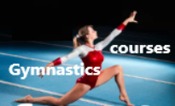

Courses available for
- Gymnastics
- Pre-school Gymnastics
- Trampolining and Rebound therapy
visit Authoritysportsuk

- General Gymnastics

- Entry Fees

- £10.00 for individual entry

- Age Groups:

- U9, U11, U13, U15, U18, O18

- These will be Split into Male and Female (In case of low numbers we reserve the right to combine

- Rules:

- Grades Floor:
Beginner (Score out of 10 points) | Intermediate (Score out of 10 points) | Advanced (Score out of 10)
- Half Twist Jump  - Star Jump  - Forward Roll to Straddle Sit  - Teddy Bear Roll (180 or 360)  - Put legs together push into Back Support back to seat.  - Lye on back into Dish  - Roll sideways to Arch Shape  - Push into Front Support jump feet in to hands  - Jump stretch to Feet  - 1 leg balance, knee at least 45 degrees (hold 2 sec) | - Full Twist Jump  - Cartwheel  - Tuck Jump  - Arabesque  - Forward Roll to Straddle Sit  - Push legs together Into Back Support  - Push to Side Support  - Into Front Support to Squat  - Jump into Forward Roll to Stand  - Half Twist Jump | - Handstand Forward roll to standing  - Tuck Jump  - Cartwheel  - Cartwheel ¼ twist to both feet  - Straddle Jump  - Backward Roll to Front Support  - Lower to ground into Arch roll to dish to lying stretch.  - Shoulder Stand then back to lying flat stretched  - Push into Bridge (hold 2 secs)  - Coming down in control into tuck rock to stretched stand.
Advanced Two (Score out of 10)
- A routine made up of the following with or without music, 1 move from A, 2 Moves from B, 2 Moves from C, 2 from optional moves then 3 moves from Beginner, Intermediate or Advanced routines above

- Moves (Moves in Red updated 31/12/21)
A | B | C | Optional
Shoulder Stand  Scissor Kick  Full Twist  Half Twist  Star Jump  Forward Roll  Backwards Roll  Bridge  Japana | Forward walkover  Backward walkover  Handstand Forward Roll  Backwards Roll to Handstand  Y Balance  Handstand pirouette ½ twist  Cat Leap full Twist  Change Leg Leap  Roundoff  Stag Leap  Pike Lever | Handspring (Front)  Handspring (Back)  Dive Forward Roll  Free Cartwheel  Flyspring  Handstand Pirouette full twist  Straddle Jump Full turn  1 ½ twist Jump  Back Flick  Front Somersault (Tucked)  Back Somersault (Tucked)  Valdez | Arabesque, Handstand, V Sit, Folded Pike, drop to front support, Front or Back support lower and push up, Splits box or sidewards, Bridge Kickover, Backwards roll to front support, Cat leap, Cat leap ½ twist, Tuck, Straddle, Pike,
- Grades Vault:
Beginner | Intermediate | Advanced | Advanced Two
- Straight Jump onto a block stretched walk to end, star jump off with safe landing  OR  - Straight Jump onto a block then immediate rebound star jump off with safe landing  Tariff for either 10.7  Block height 60cm | - Squat on Immediate Straight Jump off  OR  - Squat on Immediate Tuck Jump Off  Tariff for either 11.2  Vault or Table Height100/110 or 120 | - Squat Through  OR  - Straddle Over  Tariff for either 11.5  Vault or Table Height 100/110 or 120 | - Handspring  Tariff 12.5  Vault or Table Height 100/110 or 120
- 8 by 8-meter floor or 12 by 12-meter floor area

- Gymnast must partake in the correct competition beginner, intermediate, advanced or advanced two at the highest level they are able to do safely (i.e., if they are able to do the Advanced safely but can do the Intermediate easily and can only sometimes perform the advanced two vault and routines safely, they should do the advanced competition).

- Common rules as per set out in parts 1-6.

- Execution deductions for Vault and floor between 0.0 and 0.5

- Tiebreak if 2 competitors within the top 3 receive identical placings, the floor scores will be used as a decider for placings.

- Age Groups

- U9, U11, U13, U15, U18, O18

- These will be Split into Male and Female (In case of low numbers we reserve the right to combine)

- Competition Attire

- Male / Female gymnasts

- leotard or unitard with or without sleeves

- Gym shorts or trousers

- For reasons of safety, covering the face is not permitted.

- The wearing of jewellery or watches is not permitted during the competition video. Rings without gemstones may be worn if they are taped.
Bandages or support pieces must not create a big contrast with the skin colour. Underwear must not be visible.
Winstrada Proficiency Awards
Trampolining
Gymnastics Scheme (New Pre-school and
Disabilities Awards being introduced in Jan 2022)
Pre-school, Disabilities and Recreational.
Free Resources to view and download
Visit for more information Click Here

- Disability Gymnastics (These rules are based on Winstrada Awards Scheme and Rebound Therapy Scheme)

- Entry Fees

- £06.00 Individual Entry (Medals will be awarded for top 3 of each group)
- The competition will have six grades; 3 to 8. The competition routines are shown below (Grades 1-2 are not included as these are for in person events only)

- Grades 3+ No physical assistance permitted. Verbal prompting, signing and mirroring is permitted for all grades.

- All participants / competitors will have 1 floor routine and 1 Block / Vault Pass

- The Floor routine will be set as below however there will be a choice of 2 routines to choose from to allow those who may have issues with certain moves to still partake,
Scoring and Judging notes – Grades 3 to 8
Grade 3  Star Shape on feet into stretch straight shape into ¼ turn move  Or  Lying straight flat on back into star shape on back then roll onto tummy. | Grade 4  Star Shape on feet into stretch straight shape into ¼ turn move then balance on 1 foot.  Or  Lying straight flat on back into star shape on back then roll onto tummy show arch shape. | Grade 5  Balance on one foot then the other, sit on floor; show tuck, then pike then straddle position  Or  Lying straight flat on back into star shape on back then roll onto tummy show arch roll to dish then into sitting position.
Grade 6  Stand with good posture, Star jump x 2, Astride jump x 2, half twist jump, drop to squat, jump feet back to front support  Or  Stand with good posture, star jump, astride jump, star jump, astride jump, half twist jump, drop to squat, jump feet back to front support. | Grade 7  Stand with good posture, Star jump x 2, Astride jump x 2, half twist jump, half twist jump, drop to squat, jump feet back to front support Lower to lye stretched on floor.  Or  Stand with good posture, Star jump, Astride jump, half twist jump, Star jump, Astride jump, half twist jump, drop to squat, jump feet back to front support Lower to lye stretched on floor. | Grade 8  Stand with good posture, Forward roll to stand, Star Jump, half twist, Star jump, Drop into Squat, Jump feet back to front support, push to side support, to back support, lye into dish then roll to arch.  Or  Stand with good posture, Backward roll to stand, Star Jump, half twist, Star jump, Drop into Squat, Jump feet back to front support, push to side support, to back support, lye into dish then roll to arch.
Grades 3 to 8; no physical assistance but verbal prompting, signing and mirroring permitted
Vault Gradings: The competition is made up of 1 floor routine and 1 Vault,
Grade 3 (Light Support if required) | Grade 4 (Light Support if required)
- Straight Jump onto a block stretched walk to end, star jump off with safe landing  Tariff 10.7  Block or firm safety mats  height approx. 60cm | - Squat on Straight Jump off  OR  - Straddle on Straight Jump Off  Tariff for either 11.2  Block or firm safety mats  height approx. 60cm

Grade 5 | Grade 6 | Grade 7 | Grade 8
- Straight Jump onto a block stretched walk to end, star jump off with safe landing  OR  - Straight Jump onto a block then immediate rebound star jump off with safe landing  Tariff for either 10.7  Block or firm safety mats  height approx. 60cm | - Squat on Immediate Straight Jump off  OR  - Squat on Immediate Tuck Jump Off  Tariff for either 11.2  Vault or Table Height100/110 or 120 | - Squat on Immediate ½ Twist Jump off  OR  - Straddle on Immediate ½ Twist Jump Off  Tariff for either 11.3  Vault or Table Height 100/110 or 120 | - Squat Through  OR  - Straddle Over  Tariff 11.5  Vault or Table Height 100/110 or 120

All routines for grades 3 and above will have a maximum possible score of 10. They will be marked out of the number of skills, then the appropriate number will be added to enable the routine to show a score out of 10, as follows:

- Grade 3 comprises three moves so will be scored out of 3 and 7 will be added to the form score to bring it up to 10

- Grade 4 comprises four moves so will be scored out of 4 and 6 will be added.

- Grade 5 comprises six moves so will be scored out of 6 and 4 will be added.

- Grade 6 comprises eight moves so will be scored out of 8 and 2 will be added.

- Grade 7 comprises nine moves so will be scored out of 9 and 1 will be added.

- Grades 8 have ten moves in the routines so nothing will be added.

Scoring deductions are made as follows:

- Execution Faults: 0.1 to 0.5

- Final ‘landing’ faults – Grades 6, 7 and 8 only: 0.1 to 0.2 for instability

- A missing move in the compulsory floor (routine) will end the routine at that point.

- Grades 3, 4 and 5 - No deductions will be made for extra steps, whether during or after the routine

- Grades 6, 7 and 8 – 0.1 deductions will be made for each extra step/s during the routine.

Other notes:

- All grades – students should attempt to present at beginning and end of routine (where possible)

- Grades 4, 7 and 8 – the first move does not necessarily have to start from a standing position

- There will be no tariff (difficulty) scores.

- The routine is deemed to have started once the first skill has been performed, however a maximum of three false starts without penalty will be allowed.

- The routine is deemed to have finished after the last skill.

- Competition organisers may, if they wish, decide to award a bonus mark if the routine is performed without any assistance.

- Where there are a number of competitors in medal winning places with the same score, the senior judge should decide the placing based on his / her scoresheet. When that is not possible, the number of extra steps in the routine should be taken into account.

Medals will be awarded for 1st, 2nd and 3rd places in each category, subject to sufficient number of entrants. It is suggested that if there are only four entrants in a category for example, then medals should only be awarded for 1st and 2nd places, as there should never be just one competitor left without a medal.

Certificates will be awarded to all competitors.
- Free-Style Gymnastics (National Event)

- Entry Fees

- £10.00 for individual entry

- Age Groups:

- U9, U11, U13, U15, U18, O18

- These will be Split into Male, Female (In case of low numbers we reserve the right to combine)

- Execution Judges will take off between 0 – 0.5

- If 10 move routine is not completed the routine will be stopped at the last completed move and marked out of the number i.e. if 6 completed moves it will be marked out of 6.

- If same move is used more than 3 times in a routine 0.8 will be deducted per additional same move.

- For those not completing 10 moves there will be a 1.00 deduction

- For scoring for routine there will be the Execution score + Difficulty Score + Movement score = Total Score

List A | Difficulty | List B | Difficulty
Safety Roll  Safety Roll from Platform  Vaults  Monkey / Kong Vault  Kong Vault Walk out  Double Kong Vault  Speed Vault  Dash Vault  Floor Skills  L-Kick  Kip Up  Butterfly Kick  Palm / Wallspin on flat or slightly angled surface  Pal / Wallspin on at least 45°  Pam / Wallspin on 90° Angle  Tornado Kick  Diagonal Kick  540 Degree Kick | 0.0  0.0  0.1  0.1  0.3  0.1  0.2  0.1  0.0  0.1  0.0  0.1  0.2  0.1  0.0  0.4 | Back Somersault (Tucked)  Kick the moon  Free Cartwheel  Wallflip (Tucked)  Static Gainer  Dynamic Gainer  Corkscrew  Scoot  Macao  Movement Score  This score will be given by Chair of Judges and shall be between 0 and 1.0 mark. Based on how the routine flows and creativity, including the amount of pausing or excessive chalking. | 0.5  0.9  0.1  0.4  0.6  0.7  1.0  0.2  0.5  Movement Score  - – 1.0
- Beginner Event: The routine should be made up of 10 skills. A combination of main and linking skills from the List A may only be used.

- Requirements at least 1 Vault element, and 2 Floor Skills and any 7 other skills from List A, Note skills may be used more than once however one skill must not be used more than 3 times in a routine.

- Advanced Event: The routine should be made up of 10 skills, a combination of main and linking skills from either List A or List B.

- Requirements at least 2 moves from List B, Min 1 Vault move from List A and any 7 other moves from List A or List B, Note skills may be used more than one however one skill must not be used more than 3 times in a routine.

Entry Forms will be on www.authoritysportsuk.co.uk website to complete, these will be published a minimum of 7 days before entry date opens.

